Kittikorn Keeratikriengkrai 6188086

## Task1 – CMY

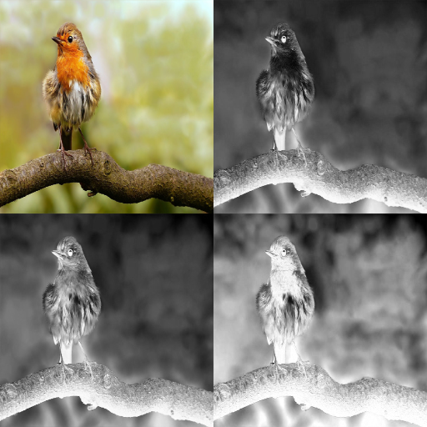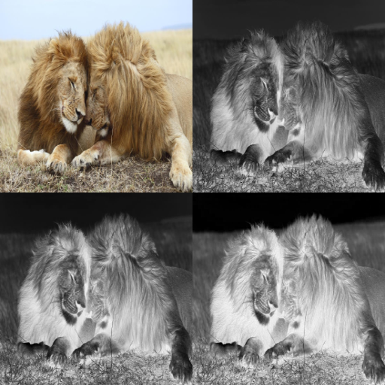

This Task is how to change RGB into CMY that have 4 channel and then show it

## Task2-CMYK

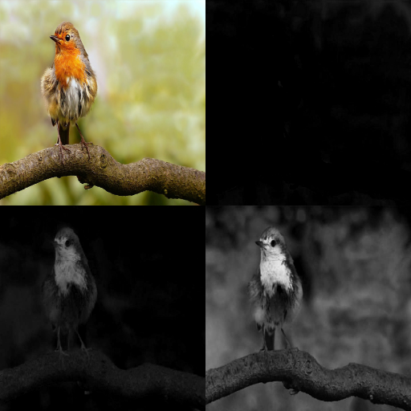

This one is same as task 1 but have more than method to find minimum of CMY then find already we will get CMY to minus min to make a photo can separate each color easier.

## Task-3: YUV(Basic), YUV(SDTV), YUV(HDTV), YIQ

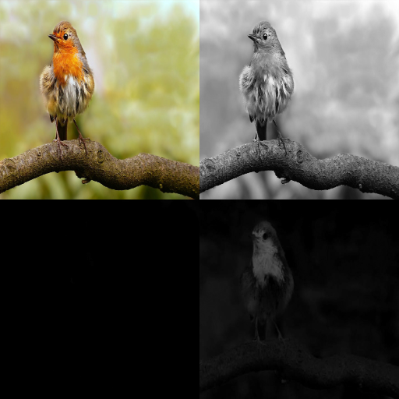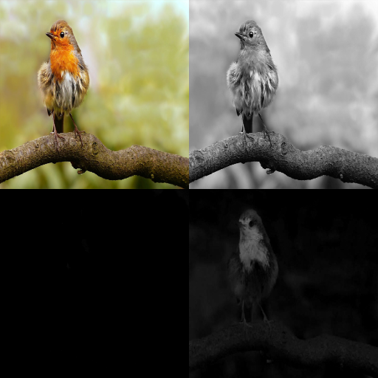

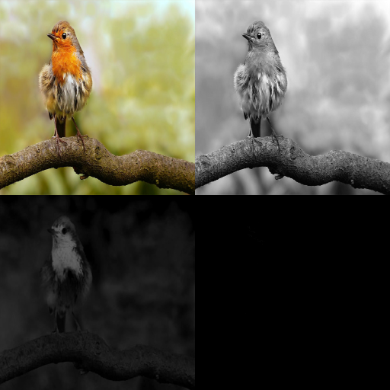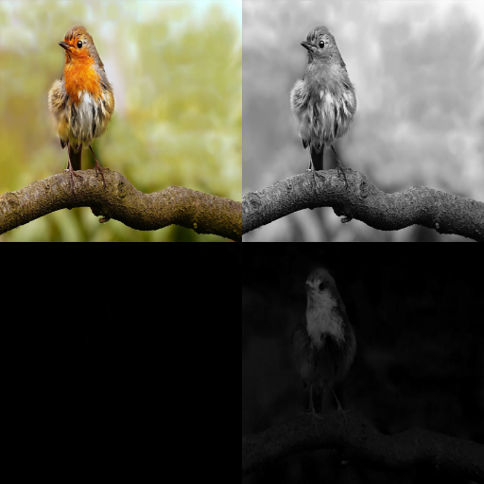 Basic SDTV

HDTV YIQ

This Task is about YUV(Basic), YUV(SDTV), YUV(HDTV), YIQ it about to adjust brightness in video game how to adjust it.

## Task-4: Save Grey image out separately from Y channel of related model

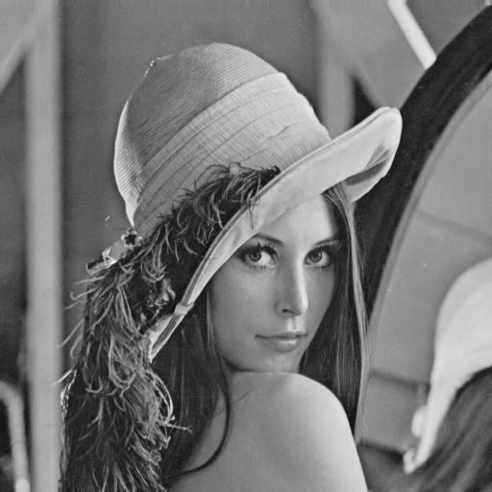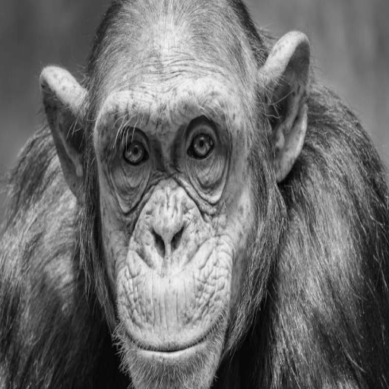

This Task is about how to get grey image using knowledge Task 1-3 to implement it.

## Task-5: Quantization of the luminance channel

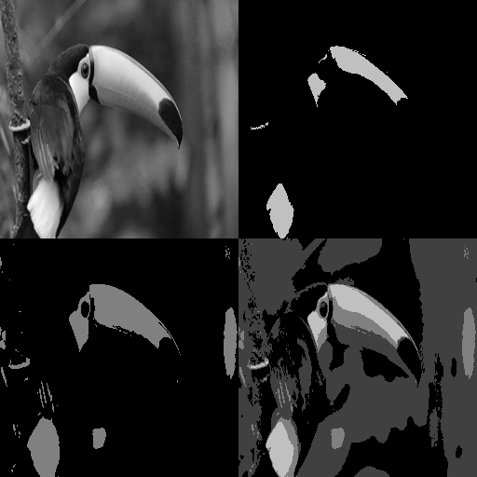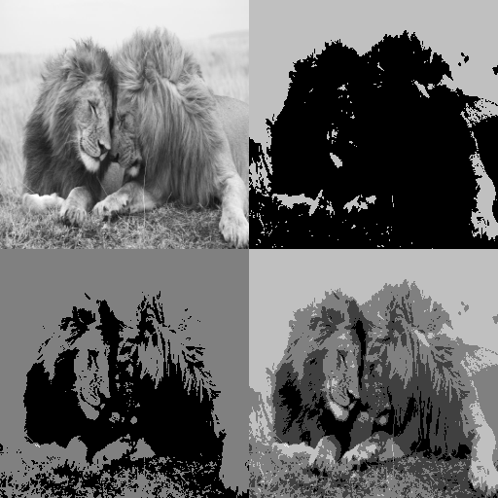

This Task is about Quantization of the luminance channel to divide the value with constant then save only the quotient coefficient but remove the remainder

## Task-6: HSB Shifting – Dynamic drawing

This task is about how to increase or decrease hue